**PolarFire Wifi click Ping test.**

**Architecture**:

ESP8266(Wifi3 Click) runs in Station mode. The architecture of the ping test demonstration is shown in below figure



**System requirement:**

Hardware detail:

* Microsemi Creative Board.
* Wifi3 Click board
* USB cable
* Wifi router
* Laptop with Wifi

Software Requirement.

* Soft Processor (For example, CoreRISCV_AXI4)
* AHB Bus (Matrix)
* SRAM
* APB Bus
* CoreUARTapb

Tools:

* FlashPro tool.
* SoftConsole 5.1

Hardware connection:

* Connect Wifi3 Click board to mikroBUS connector present in Microsemi PolarFire Creative board. Microsemi Creative board and Wifi Click board communicate over UART terminal.
* Connect the Microsemi creative board to the PC through Micro USB cable. User should make sure that UART driver is installed on PC.
* Connect the Laptop to the Wifi router. After loading the demo example project user should able to perform ping operation.
* Also make sure that the SoftConsole tool latest version is installed on your PC.

**Testing Procedure: Setting WiFi Click to Station Mode for Ping Test**

1. Load the PingTest.stp file into Microsemi Creative board using FlashProTool chain.
2. Connect the Laptop or PC to the WiFi router. Suppose the SSID of the target router is "Microsemi_Guest" and no password.
3. Power on the Microsemi Creative board, Wifi Click board will also power up.

Wifi click board start sending firmware installation detail through UART terminal at the 74880 baud rate. Wifi Click board will send these detail till it’s get ready. After the Wifi Click board is ready, it will set the baud rate to 115200. In example project we are waiting 5 seconds to send the AT commands.

1. Compile and load the Ping test demo example project in Microsemi Creative board using Microsemi SoftConsole tool. And connect Wifi Click to the same router.

The Ping test demo example project will send AT command to Wifi Click board and the command execution information will be displayed on UART terminal. The demo example project also displays the assigned IP on UART terminal. (Snapshot for reference.)

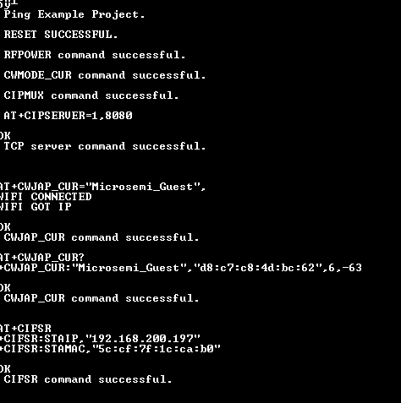

Note:

The Ping test demo example project is configured to connect Microsemi guest router. User should change the below parameter present in main.c file according to the Wifi Router setting.

const char SSID[] = "Microsemi_Guest";

const char password[] = "";

1. Running command prompt on the PC again, and input the command shown below to

ping Wifi Click Station (IP address is 192.168.200.197 in this case) as shows above in UART snapshot.

1. The result of ping test is as shown below:

